DISCERNERS’ GATHERING
YOU’RE INVITED to a gathering of the New England churches who have started the discernment process regarding possible disaffiliation from the United Methodist Church. Anyone and everyone who is connected with this discernment process is welcome to join us on Saturday, January 11th, 9 AM to 3 PM at HopeGateWay UMC in Portland.
This is a great opportunity to meet with others who share some of the hopes and struggles that you have been addressing in your own context. We can compare our progress, strategize next steps, and be present for each other in this journey that can be both exciting and overwhelming.
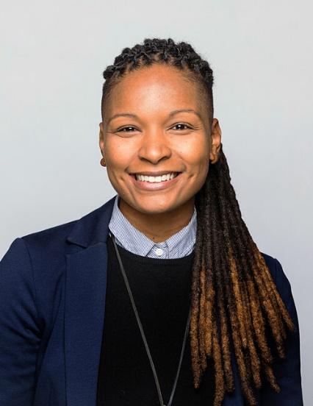
Our special guest for the day is Dr. Elyse Ambrose. She describes herself as “a black queer woman” and as “an educator, sexual ethicist and creative.” Elyse’s research, justice work, and art lies at the intersections of race, sexuality, gender, and spirituality.
Many of us did not know the term “intersectional” until it became part of the vocabulary in our discernment sessions. Elyse will help us focus on how “right relationships are at the center of justice.”
This gathering is hosted by HopeGateWay UMC, 509 Forest Ave., Portland, ME. The program will run from 9:00 am to 3:00 pm. Every attendee is asked to bring $10 to help cover the cost of lunch. (We’re getting Leonardo’s pizza and salad.)
Street parking is available on Forest Avenue and many residential streets in the neighborhood. Also, free evening and weekend parking is available in an underground parking garage. Just beyond Casco Bay Movers dance studio and Portland Ballet (one unit beyond HopeGateWay), turn into an alley that ramps downward to a garage door. As you approach the door, you will see a keypad on your left. Use the code 1101* (asterisk), and the door will open. Park anywhere and take the elevator or stairs to the first floor. Exiting the elevator, walk through the double doors, and you will see HopeGateWay on your right.
FMI and car-pooling, please contact Gloria Brown, gjbrown58a@gmail.com

